Introduction to 3D slicer:

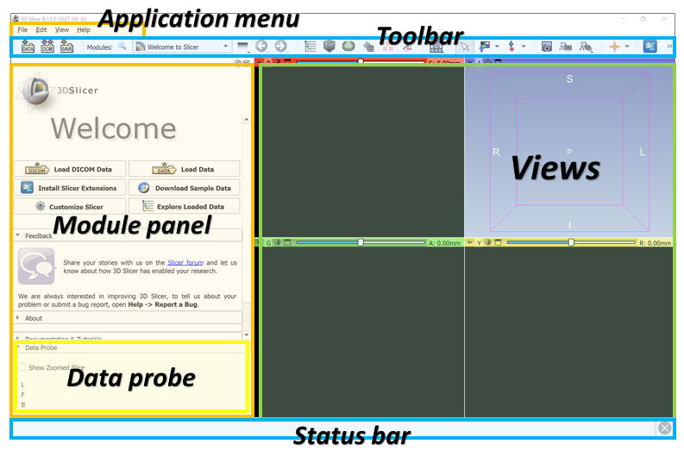

Layout icon: change the layout of four panels of images; “four up” is usually used.

Conventional: three axis at the bottom

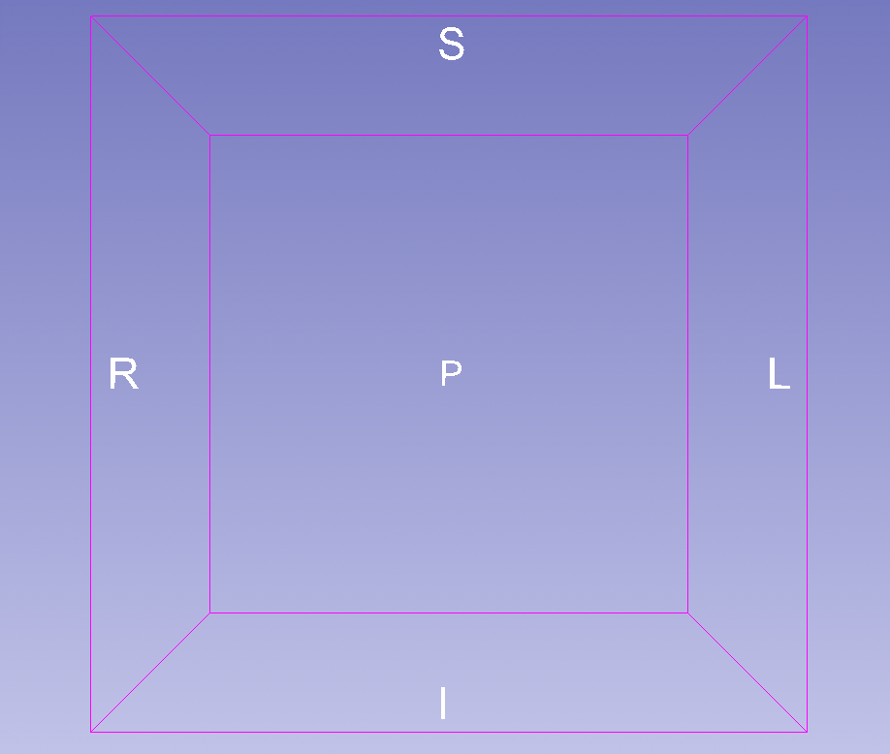

A = anterior, P = posterior, R = right, L = left, S = superior and I = inferior.

* Loading data: (drag and drop)
* Cropping (crop volume module and volume rendering module):
* Creating Label Map (Editor module: threshold effect and change island effect):
* Building Model:
* Saving Model:

Case study (**04/2022**) – CT of spleen:

<https://radiopaedia.org/articles/spleen-1>

<https://insightsimaging.springeropen.com/articles/10.1007/s13244-012-0202-z>

* Data from MSD; venous phase from patients undergoing chemotherapy treatment for liver metastases. ROI 🡪 spleen; selected due to large variations in the FOV
* Wedge-shaped, left upper quadrant (superior + left)

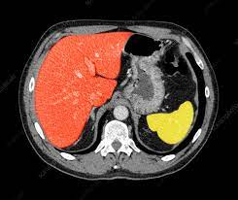

Liver (red) + spleen (yellow)

1. Resampling volume:

Module = “Resample scalar volume”

spacing = 1,1,1; interpolation = linear, NearestNeighbor; bspline …

input volume = its original file name

output volume = create your own name (better include new spacing info)

1. Cropping volume:

Go to “vendering volume” 🡪 use the ROI 3d box to select regions

Go to crop volume 🡪 apply

note: go to “Data” 🡪 turn on ROI to select regions

1. Segment editor: (at least **2 segmented** regions are required)

Add: edit name + double click to edit color (spleen == dark purple)

Create seeds: manually paint ROI in different views

Grow seed 🡪 initialize 🡪 apply

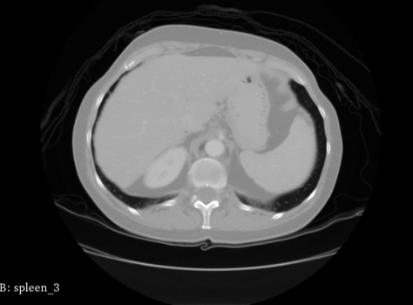

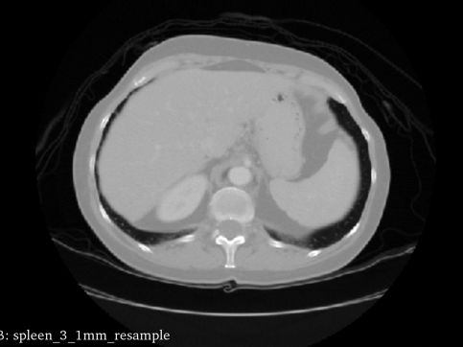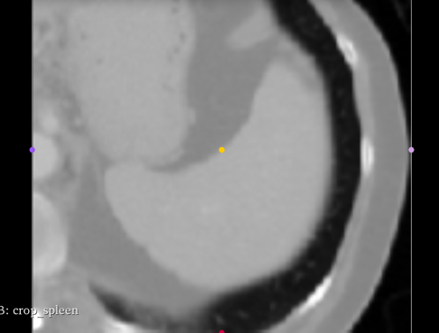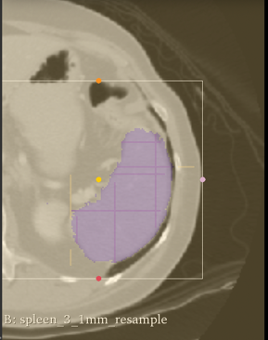

Case study (04/12) – mp-MRI of Brain tumor (4D volumes)

* Chosen due to complex and heterogeneously located targets
* 750 images

Resampling 🡪 registration 🡪 bias correction 🡪 skull stripping 🡪 normalization

mp-MRI: multiparametric MRI (native T1-weighted, post-Gadolinium contrast T1-weighted (T1-Gd), native T2-weighted, T2 Fluid Attenuated Inversion Recovery (FLAIR))

<https://case.edu/med/neurology/NR/MRI%20Basics.htm>

dim = (240, 240, 155, 4); sequence: T1 🡪 T1-Gd 🡪 T2 🡪 FLAIR

target ROI: edema (build-up fluid in tissue), enhancing, non-enhancing

* For peripherally enhancing masses, the main differential diagnosis lies between **high-grade and secondary brain tumors, inflammatory or demyelinating lesions and abscesses**. HGG (fast-growing, hard to treat)
* Non-enhancing lesions may represent **low-grade gliomas (LGGs), viral encephalitis and developmental anomalies**, such as focal cortical dysplasia. LGG (longer-term survival in younger patients)

Question: seemed already skull stripped ?????

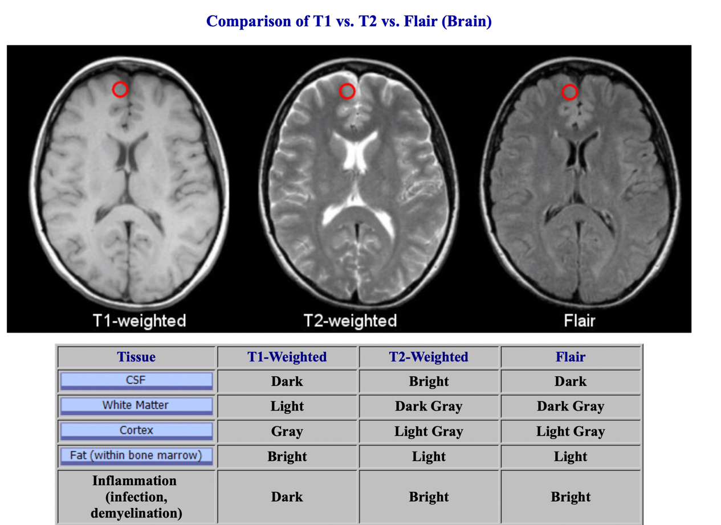

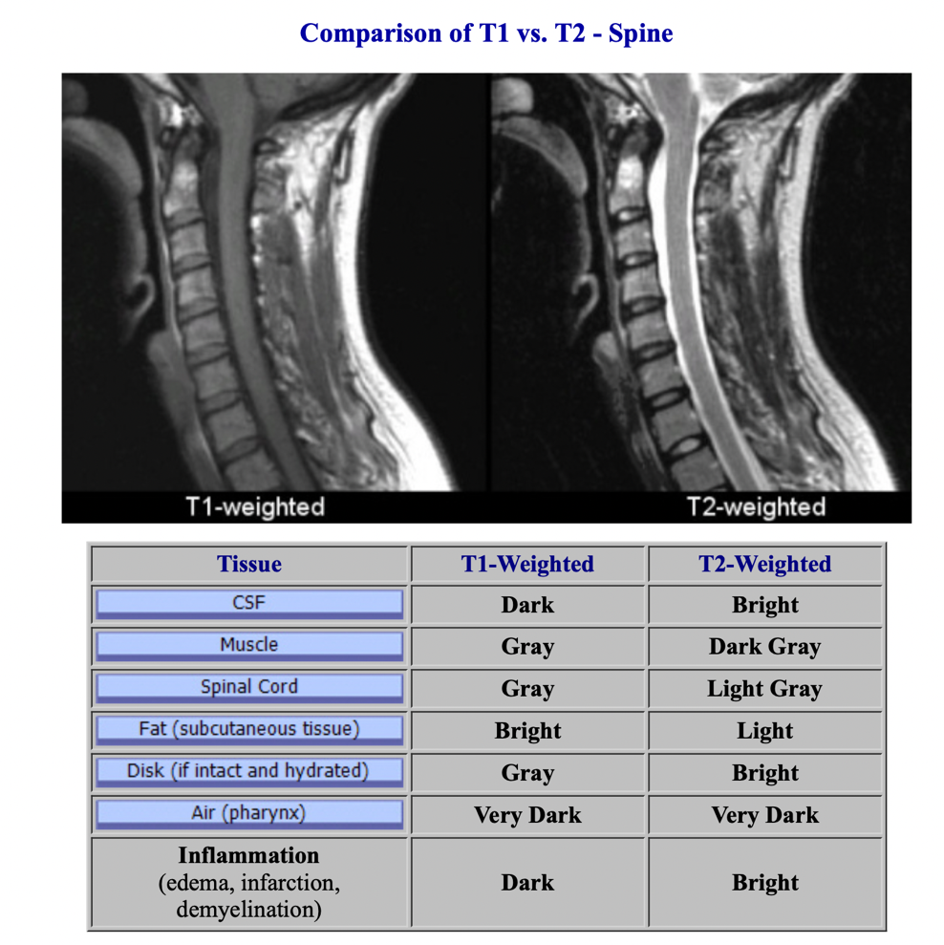

DICOM: digital imaging and communications in medicine

NIfTI: neuroimaging informatics technology initiative

**CT windowing:** <https://www.kaggle.com/code/redwankarimsony/ct-scans-dicom-files-windowing-explained/notebook>

Windowing, also known as **grey-level mapping**, **contrast stretching**, **histogram modification** or **contrast enhancement** is the process in which the CT image greyscale component of an image is manipulated via the CT numbers; doing this will change the appearance of the picture to highlight particular structures. The brightness of the image is adjusted via the window level. The contrast is adjusted via the window width.

Tissue density is measured in [Hounsfield units (HU)](https://en.wikipedia.org/wiki/Hounsfield_scale)

* This is defined as **Air = −1000 HU**; **Water = 0 HU.**

Density of tissues in CT-Scans:

𝐴𝑖𝑟<𝐹𝑎𝑡<𝐹𝑙𝑢𝑖𝑑<𝑆𝑜𝑓𝑡𝑡𝑖𝑠𝑠𝑢𝑒<𝐵𝑜𝑛𝑒<𝑀𝑒𝑡𝑎𝑙Air<Fat<Fluid<Softtissue<Bone<Metal

The easier way to remember this is (Fat floats on water, so is less dense than fluid; Soft tissue is mostly intracellular fluid with some connective tissue)

* Air = −1000 HU
* Lung ≈ −500 HU (partially air, partially soft tissue)
* Fat ≈ −50 HU (slightly less dense than simple fluid)
* Water = 0 HU
* Soft tissue (& blood) ≈ +50 HU (slightly more dense than simple fluid)
* Bone ≈ +1000 HU (much more dense)

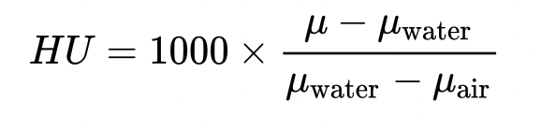

To ascertain a window, a ‘level’ and a ‘width’ is defined. For example, a window with a level of 0 HU and a width of 400 HU will have a range of −200 HU to +200 HU. Any tissue with a density of −200 HU or less will be black, and any tissue with a density of +200 HU or more will be white. And values between -200 HU to +200 HU will be spread between the whole grayscale range. A **window** can be set to look at certain tissues of interest. **A small range of tissue density is represented by a full greyscale spectrum from black to white, thus making subtle density differences within the specified range easier to see.**

### Typical window width and level values:

Although this varies somewhat from institution to institution and vendor to vendor, window width and centers are generally fairly similar. **The values below are written as width and level (W:x L:y) in Hounsfield units (HU).**

* head and neck
* brain W:80 L:40
* subdural W:130-300 L:50-100
* stroke W:8 L:32 or W:40 L:40 3
* temporal bones W:2800 L:600
* soft tissues: W:350–400 L:20–60 4
* chest
* lungs W:1500 L:-600
* mediastinum W:350 L:50
* abdomen
* soft tissues W:400 L:50
* liver W:150 L:30
* spine
* soft tissues W:250 L:50
* bone W:1800 L:400

w: window width

L: window center

img = (img*slope +intercept) *#for translation adjustments given in the dicom file.*

img_min = window_center - window_width//2 *#minimum HU level*

img_max = window_center + window_width//2 *#maximum HU level*

img[img<img_min] = img_min *#set img_min for all HU levels less than minimum HU level*

img[img>img_max] = img_max *#set img_max for all HU levels higher than maximum HU level*

if rescale:

img = (img - img_min) / (img_max - img_min)*255.0

return img

Apr 27, 2022, Wed:

Full preprocessing tutorial: <https://www.kaggle.com/code/gzuidhof/full-preprocessing-tutorial/notebook>

Image View Position: <http://www.grahamwideman.com/gw/brain/orientation/orientterms.htm>

Orientation: <https://www.aliza-dicom-viewer.com/manual/orientation>

Code reference: <https://vincentblog.xyz/posts/medical-images-in-python-computed-tomography>

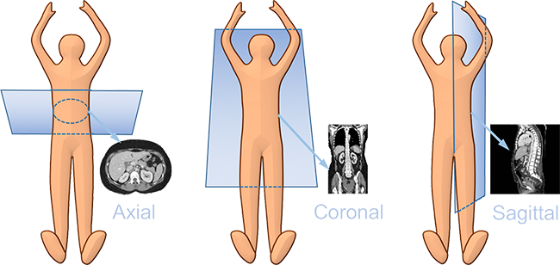

Original vs. Windowing:

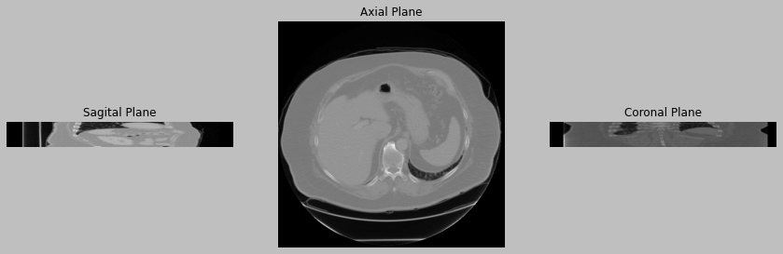



Cropped & Resampled & Windowed Images through ROI reference:

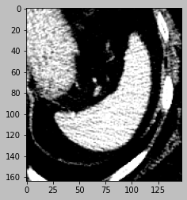

May 2, 2021, Mon: meeting

Onboarding (estimated at the beginning of June):

* receive email from HireRight 🡪 finish background check
* background check takes up to 3 weeks 🡪 receive confirmation number
* send confirmation # back to HR 🡪 receive MGH email from HR

Parameters to tune:

* model hyperparameters
* preprocessing parameters (rule-based)???

U-Net: try segmentation project with 2D CT images (Kaggle)

* Q: **should we consider taking just 2D slices since lack of training samples**

Anything to do without using lab computer:

* Try dataset one by one? 2D or 3D

May 5, 2022, Thu: MRI reorientation

Align ROI and images by rotation

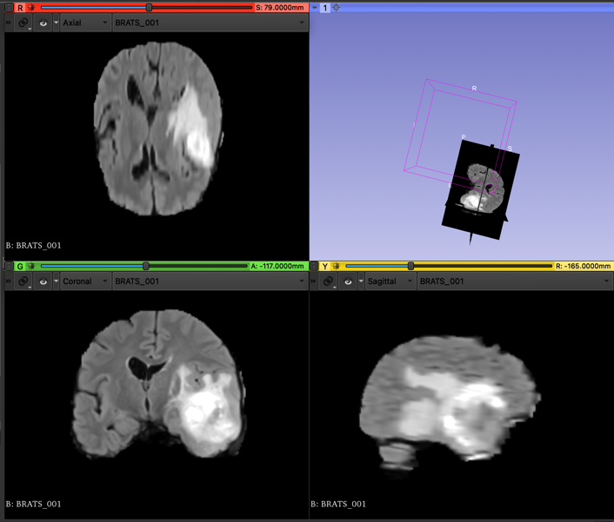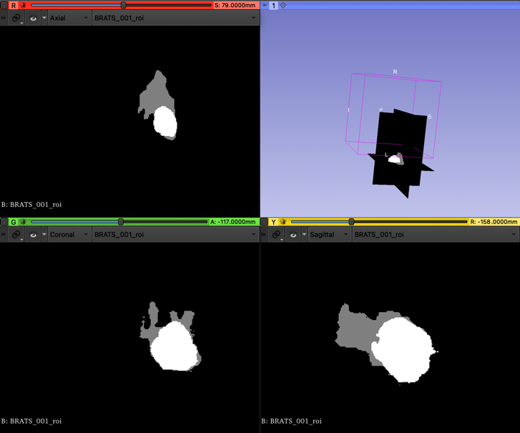

N4BiasCorrection

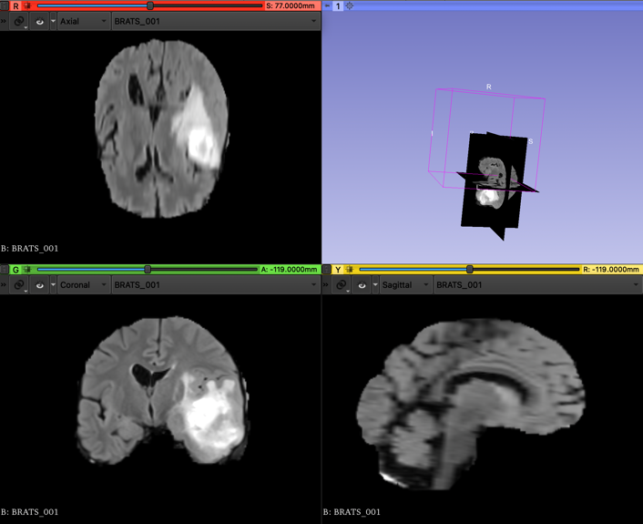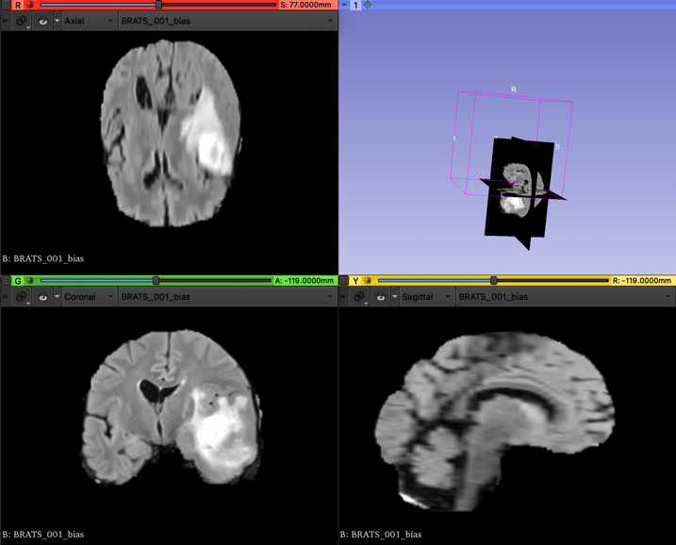

**May 13, 2022, Fri: meeting with Jay and Ben (lab computer)**

* Log in terminal: ssh [yy908@glacier.nmr.mgh.harvard.edu](mailto:yy908@glacier.nmr.mgh.harvard.edu)
* Put data and code in “**project” and “data”** folder: local_mount/space/glacier/1
* **dockerhub** 🡪 **register an account (use ubuntu containers; tensorflow containers):** docker run --gpus '"device=0:0"' --rm -it -v /local_mount/space/glacier/1/data/:/april -v /local_mount/space/glacier/1/projects/april/:/app tensorflow/tensorflow:latest-gpu bash
* docker run –rm … (good habit: if done with something, go delete the container)

**GPU and deep learning packages:**

* search tensorflow image with cuda (find them on docker hub when setting up an image/container)
* Ben already pulled it so I can directly use it

docker run -it --rm --gpus '"device=0:0"' projectmonai/monai nvidia-smi

(real gpu : virtual gpu)

* vscode: remote ssh (extension needs to be installed; already installed!)
* ctrl + shift + p
* ctrl + tilt (open terminal)

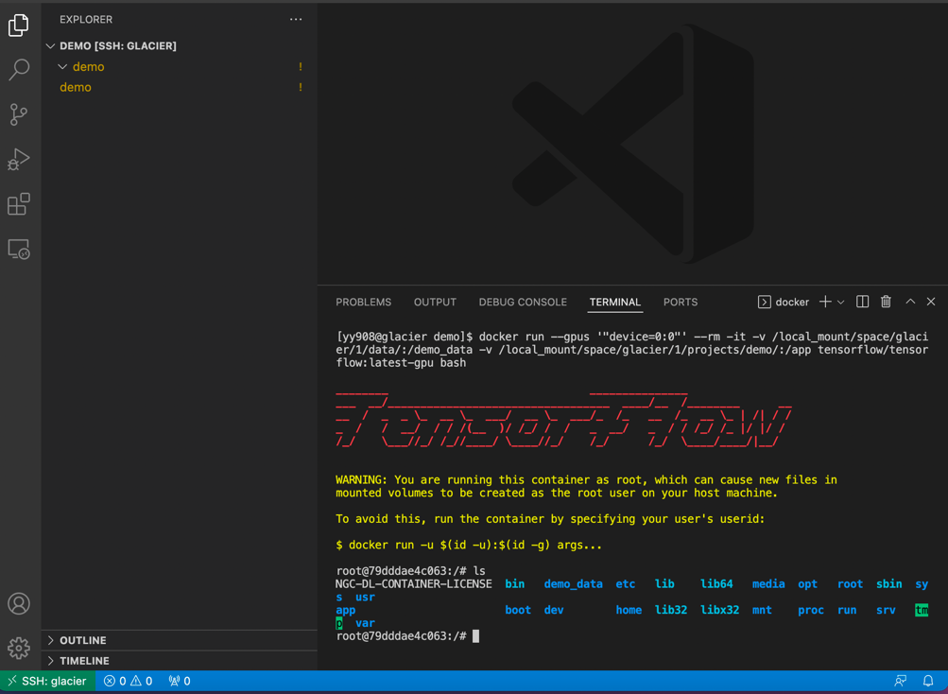

* if using Jupyter notebook, remember changing kernel (already there: python 3.8.10)

Change container/glacier:

* Command + shift + p: type **remote ssh** or **remote container**

Sign up availability before and after using GPU:

* <https://docs.google.com/spreadsheets/d/1oJ3h7CumO_UEXJsSxRt_lcvRJBNaqOZ5mJlWKT9aBlY/edit#gid=0>

vim: save all your user names

**Next step:**

* Create data + code folder
* Move brain images?? Or CT
* Use a few images to build the U-Net model
* Brain preprocessing

May 23, Mon, 2022:

Document 🡪 open folder 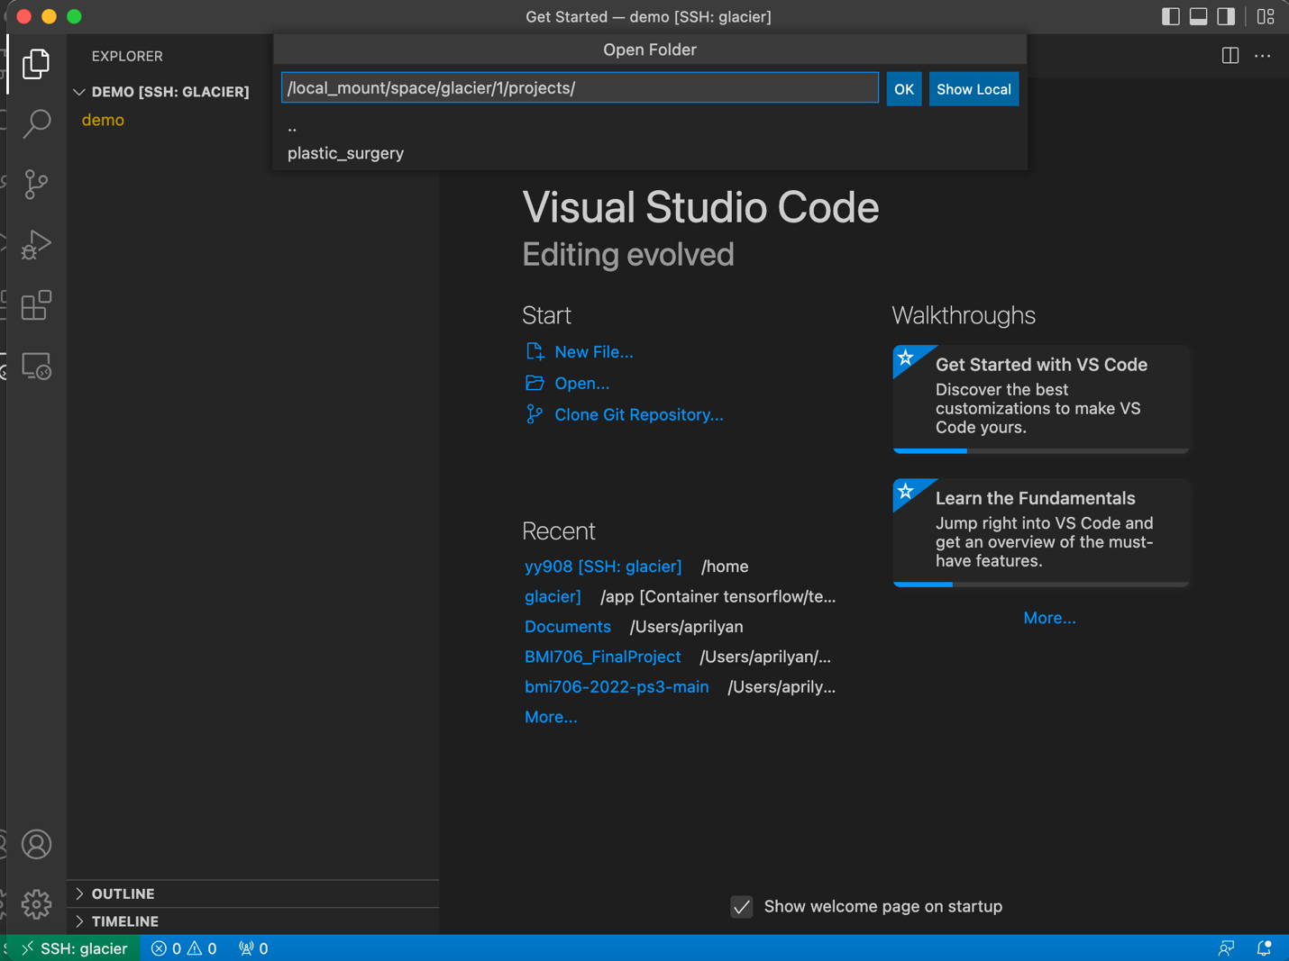

Steps:

1. Command + shift + p: open ssh remote 🡪 connect to glacier
2. Build the container:

docker run --gpus '"device=1:1"' --name ayan_temp --rm -it -v /local_mount/space/glacier/1/data/:/april_data -v /local_mount/space/glacier/1/projects/april_project/:/app tensorflow/tensorflow:latest-gpu bash

1. Ctrl + shift + p: open remote container (select the one built just now). Everything will be synced in the container (i.e., virtual machine)
2. When entering code, change kernel to python 3.8.10

Attach + detach:

* In terminal: ctrl + p + q (detach)

FileZilla: move large data files/folders to glacier

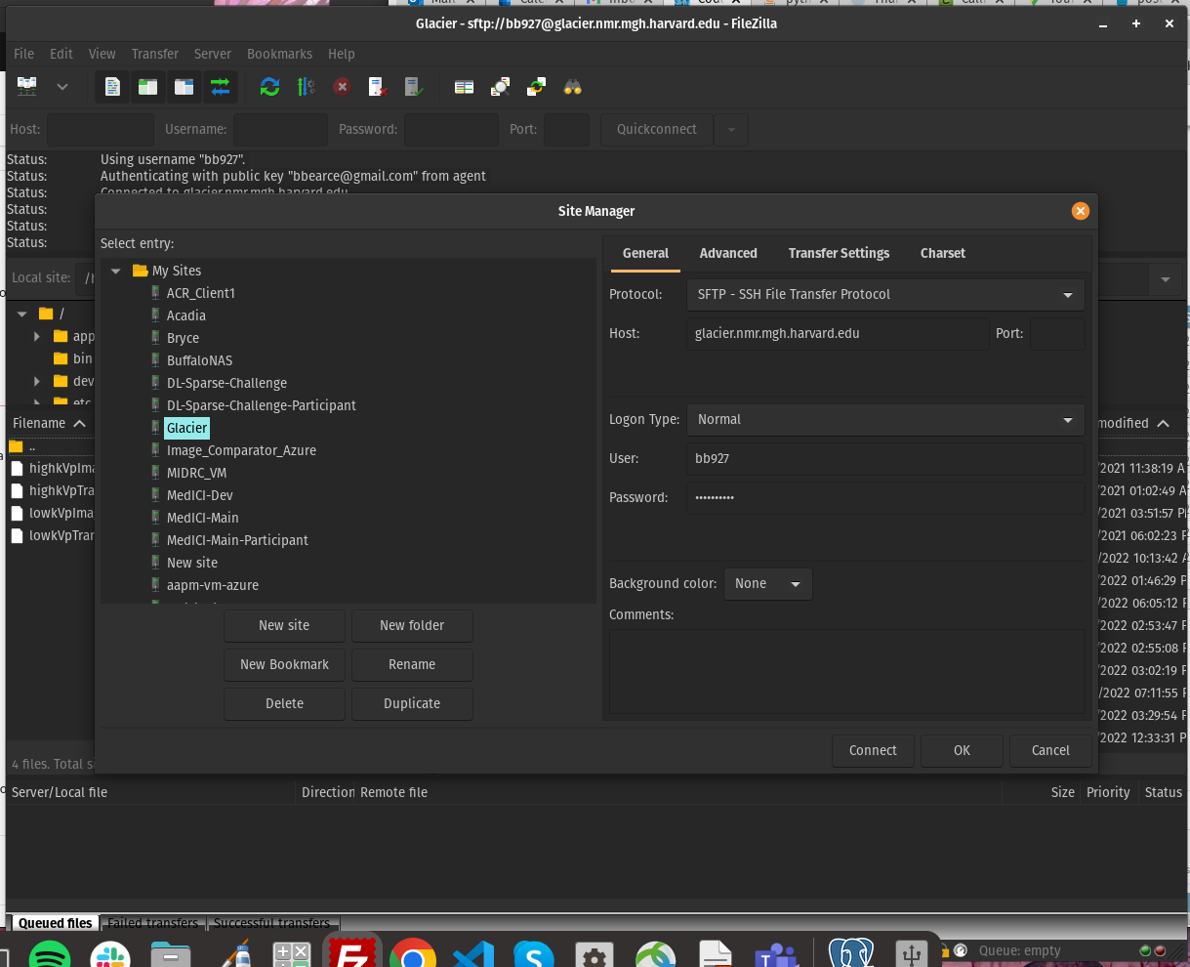

docker run --gpus '"device=0:0"' --name april_project_gpu0 --rm -it -v /local_mount/space/glacier/1/data/april_data/:/data -v /local_mount/space/glacier/1/projects/april_project/:/app jaybpatel/jay_tensorflow2.2:latest bash

--detach-keys=”ctrl-[”

May 29, 2022, Sun: preprocessing coding

* Resampling: change voxel spacing to 1,1,1

Img.header[‘pixdim’]:

The codes below can be used in xyzt_units to indicate the units of pixdim.

As noted earlier, dimensions 1,2,3 are for x,y,z; dimension 4 is for

time (t).

- If dim[4]=1 or dim[0] < 4, there is no time axis.

- A single time series (no space) would be specified with

- dim[0] = 4 (for scalar data) or dim[0] = 5 (for vector data)

- dim[1] = dim[2] = dim[3] = 1

- dim[4] = number of time points

- pixdim[4] = time step

- xyzt_units indicates units of pixdim[4]

- dim[5] = number of values stored at each time point

ANTS: N4BiasCorrection:

cd

ls -a

vi .bashrc

*#ANTs*

export PATH=/usr/local/antsbin/bin:$PATH

export ANTSPATH=/usr/local/antsbin/bin/

Original Images:

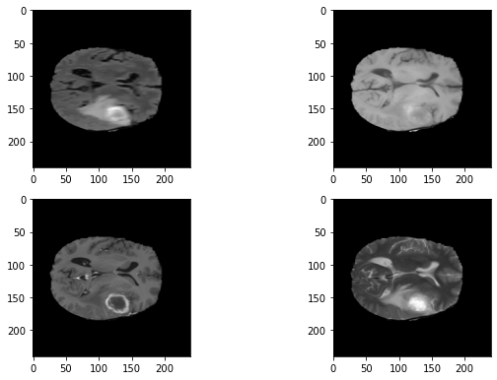

Bias corrected:

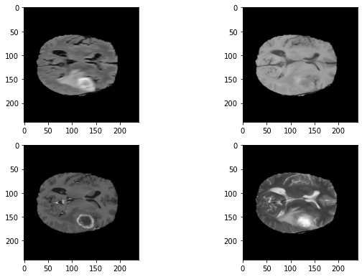

Normalized:

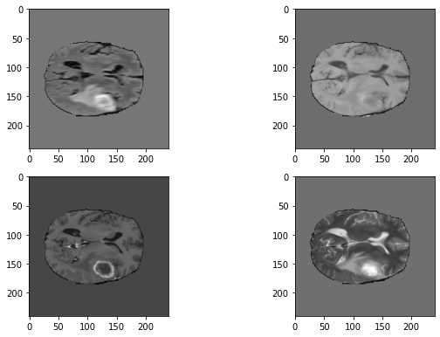

**June 15, Wed, 2022**

brain

docker run --gpus '"device=0:1"' --name april_pancreas_segment_1 --rm -it -v /local_mount/space/glacier/1/data/april_data/pancreas_temp/:/home/neural_network_code/Data/Patient -v /local_mount/space/glacier/1/projects/april_project/Code/:/home/neural_network_code/Code jaybpatel/jay_tensorflow2.2:latest bash

docker cp c36786f9e6d9:/home/neural_network_code/Model/model_outputs/0_aug1/ /home/yy908/model_output/0_aug1

docker cp c36786f9e6d9:/home/neural_network_code/Model/model_outputs/0_aug1.txt /home/yy908/model_output/0_aug1.txt

docker cp c36786f9e6d9:home/neural_network_code/Data/Patients/Val/BRATS_306/ /home/yy908/data_test/BRATS_306_aug

docker cp c36786f9e6d9:home/neural_network_code/Data/Patients/Test/BRATS_430/ /home/yy908/data_test/BRATS_430_aug

Pancreas:

docker run --gpus '"device=0:1"' --name april_pancreas_segment --rm -it -v /local_mount/space/glacier/1/data/april_data/Patients_Pancreas/:/home/neural_network_code/Data/Patients -v /local_mount/space/glacier/1/projects/april_project/Code/:/home/neural_network_code/Code jaybpatel/jay_tensorflow2.2:latest bash

docker run --gpus '"device=0:1"' --name april_pancreas_segment --rm -it -v /local_mount/space/glacier/1/data/april_data/Patients_Pancreas/:/home/neural_network_code/Data/Patients -v /local_mount/space/glacier/1/projects/april_project/Code/:/home/neural_network_code/Code tensorflow/tensorflow:latest-gpu bash

* docker run --gpus '"device=0:0"' --rm -it -v /local_mount/space/glacier/1/data/:/april -v /local_mount/space/glacier/1/projects/april/:/app tensorflow/tensorflow:latest-gpu bash

docker cp 4adc9fc3019b: :/home/neural_network_code/Model/model_outputs/ /home/yy908/pancreas_output

* Logout: type exit
* Detach from container: ctrl p + ctrl q (delete default in VS code)
* Open terminal in VS: ctrl + ` (tilt)
* Open search bar: command + shift + p

Epoch1: 364/364 - 1886s - hard_dice_coef_metric: 0.3725 - dice_coef_metric: 0.3600 - loss: 0.6400 - val_hard_dice_coef_metric: 0.3864 - val_dice_coef_metric: 0.3830 - val_loss: 0.6170

Epoch2: 364/364 - 1147s - hard_dice_coef_metric: 0.5329 - dice_coef_metric: 0.5295 - loss: 0.4705 - val_hard_dice_coef_metric: 0.5700 - val_dice_coef_metric: 0.5654 - val_loss: 0.4346

Epoch3: 364/364 - 883s - hard_dice_coef_metric: 0.5726 - dice_coef_metric: 0.5701 - loss: 0.4299 - val_hard_dice_coef_metric: 0.5756 - val_dice_coef_metric: 0.5736 - val_loss: 0.4264

Epoch4 364/364 - 883s - hard_dice_coef_metric: 0.5866 - dice_coef_metric: 0.5846 - loss: 0.4154 - val_hard_dice_coef_metric: 0.5660 - val_dice_coef_metric: 0.5648 - val_loss: 0.4352

Epoch5: 364/364 - 884s - hard_dice_coef_metric: 0.6027 - dice_coef_metric: 0.6011 - loss: 0.3989 - val_hard_dice_coef_metric: 0.6286 - val_dice_coef_metric: 0.6272 - val_loss: 0.3728

…

Epoch15: 364/364 - 882s - hard_dice_coef_metric: 0.6721 - dice_coef_metric: 0.6713 - loss: 0.3287 - val_hard_dice_coef_metric: 0.6602 - val_dice_coef_metric: 0.6596 - val_loss: 0.3404

Epoch16: 364/364 - 882s - hard_dice_coef_metric: 0.6787 - dice_coef_metric: 0.6781 - loss: 0.3219 - val_hard_dice_coef_metric: 0.6915 - val_dice_coef_metric: 0.6909 - val_loss: 0.3091

Epoch 102/1000 (**overfitting???**)

364/364 - 897s - hard_dice_coef_metric: 0.8093 - dice_coef_metric: 0.8085 - loss: 0.1915 - val_hard_dice_coef_metric: 0.6972 - val_dice_coef_metric: 0.6969 - val_loss: 0.3031

Epoch179: (**not too bad…**)

364/364 - 931s - hard_dice_coef_metric: 0.7470 - dice_coef_metric: 0.7465 - loss: 0.2535 - val_hard_dice_coef_metric: 0.7062 - val_dice_coef_metric: 0.7059 - val_loss: 0.2941

Epoch289:

364/364 - 899s - hard_dice_coef_metric: 0.8578 - dice_coef_metric: 0.8570 - loss: 0.1430 - val_hard_dice_coef_metric: 0.6988 - val_dice_coef_metric: 0.6986 - val_loss: 0.3014

Epoch 364/1000

364/364 - 964s - hard_dice_coef_metric: 0.8534 - dice_coef_metric: 0.8530 - loss: 0.1470 - val_hard_dice_coef_metric: 0.7050 - val_dice_coef_metric: 0.7048 - val_loss: 0.2952

**July 8, 2022, Fri:**

Model without augmentation is overfit, look at some test, validation examples

Val: BRATS_306

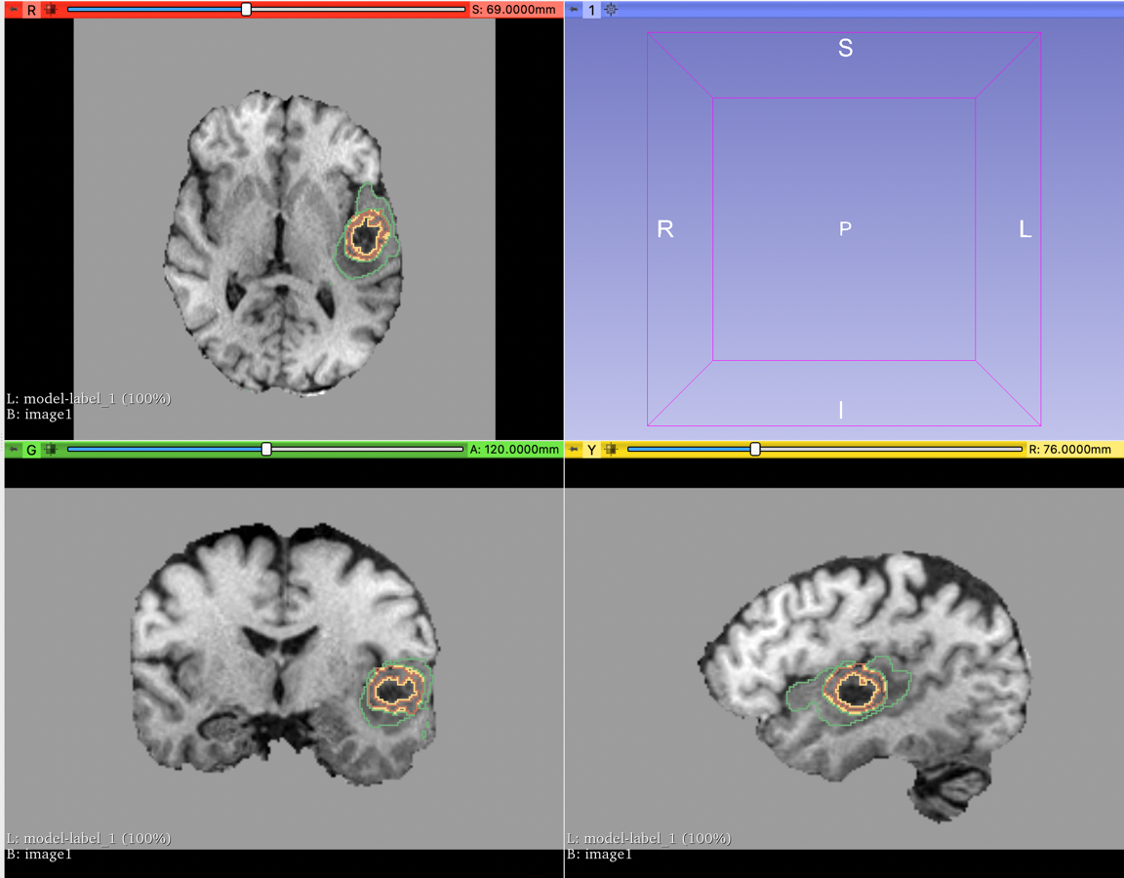

Test: BRATS_430

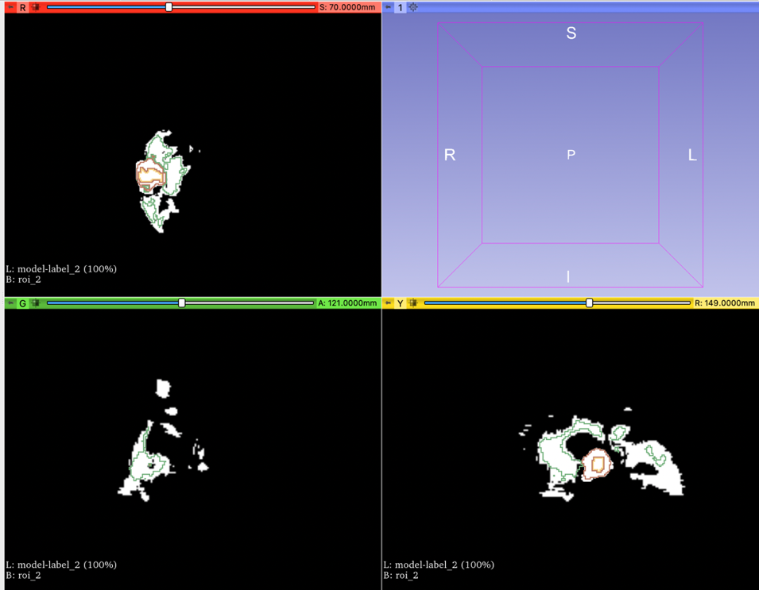

Convert predicted regions to contours:

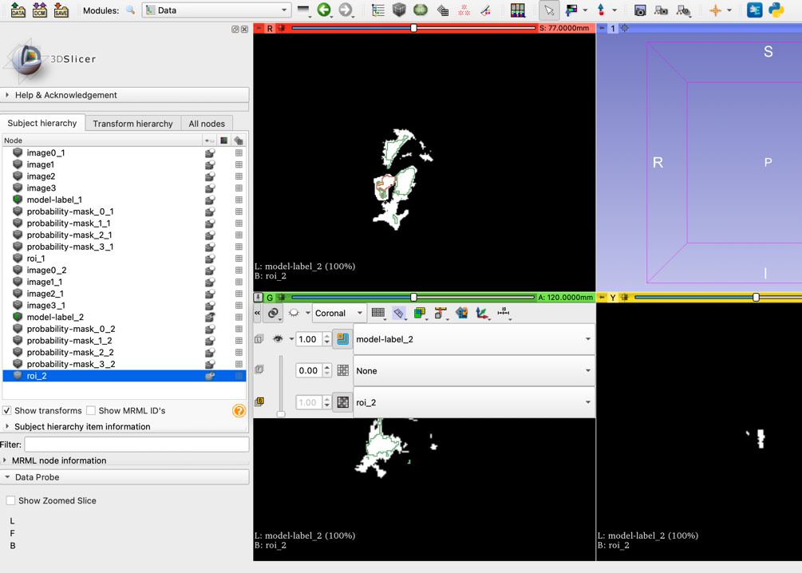

Augmentation_brain_tumor:

Epoch1: 364/364 - 1731s - loss: 0.6220 - hard_dice_coef_metric: 0.3898 - dice_coef_metric: 0.3780 - val_loss: 0.5680 - val_hard_dice_coef_metric: 0.4393 - val_dice_coef_metric: 0.4320

Epoch2: 364/364 - 1092s - loss: 0.4677 - hard_dice_coef_metric: 0.5363 - dice_coef_metric: 0.5323 - val_loss: 0.4626 - val_hard_dice_coef_metric: 0.5413 - val_dice_coef_metric: 0.5374

Epoch3: 364/364 - 888s - loss: 0.4423 - hard_dice_coef_metric: 0.5601 - dice_coef_metric: 0.5577 - val_loss: 0.3873 - val_hard_dice_coef_metric: 0.6150 - val_dice_coef_metric: 0.6127

Epoch4: 364/364 - 882s - loss: 0.4299 - hard_dice_coef_metric: 0.5719 - dice_coef_metric: 0.5701 - val_loss: 0.4475 - val_hard_dice_coef_metric: 0.5535 - val_dice_coef_metric: 0.5525

Epoch 5: 364/364 - 882s - loss: 0.4158 - hard_dice_coef_metric: 0.5856 - dice_coef_metric: 0.5842 - val_loss: 0.4289 - val_hard_dice_coef_metric: 0.5723 - val_dice_coef_metric: 0.5711

…

Epoch34: 364/364 - 882s - loss: 0.3550 - hard_dice_coef_metric: 0.6450 - dice_coef_metric: 0.6450 - val_loss: 0.3057 - val_hard_dice_coef_metric: 0.6948 - val_dice_coef_metric: 0.6943

Epoch99: 364/364 - 907s - loss: 0.3013 - hard_dice_coef_metric: 0.6989 - dice_coef_metric: 0.6987 - val_loss: 0.2829 - val_hard_dice_coef_metric: 0.7173 - val_dice_coef_metric: 0.7171

Epoch203: 364/364 - 887s - loss: 0.2776 - hard_dice_coef_metric: 0.7224 - dice_coef_metric: 0.7224 - val_loss: 0.2780 - val_hard_dice_coef_metric: 0.7221 - val_dice_coef_metric: 0.7220

This one has dice_coef vanished …

**Another training with 500 epochs**:

different probability for augmentation methods [deform = 0.1, translation = 0.1, others = 0.5]

epoch1: 364/364 - 1675s - hard_dice_coef_metric: 0.4158 - dice_coef_metric: 0.4044 - loss: 0.5956 - val_hard_dice_coef_metric: 0.5015 - val_dice_coef_metric: 0.4973 - val_loss: 0.5027

epoch2: 364/364 - 1098s - hard_dice_coef_metric: 0.5248 - dice_coef_metric: 0.5219 - loss: 0.4781 - val_hard_dice_coef_metric: 0.5354 - val_dice_coef_metric: 0.5326 - val_loss: 0.4674

epoch3: 364/364 - 880s - hard_dice_coef_metric: 0.5428 - dice_coef_metric: 0.5405 - loss: 0.4595 - val_hard_dice_coef_metric: 0.5180 - val_dice_coef_metric: 0.5166 - val_loss: 0.4834

epoch4: 364/364 - 881s - hard_dice_coef_metric: 0.5654 - dice_coef_metric: 0.5643 - loss: 0.4357 - val_hard_dice_coef_metric: 0.5804 - val_dice_coef_metric: 0.5788 - val_loss: 0.4212

…….

Epoch55: 364/364 - 880s - hard_dice_coef_metric: 0.6875 - dice_coef_metric: 0.6872 - loss: 0.3128 - val_hard_dice_coef_metric: 0.6976 - val_dice_coef_metric: 0.6971 - val_loss: 0.3029

Epoch143: 364/364 - 881s - hard_dice_coef_metric: 0.7365 - dice_coef_metric: 0.7362 - loss: 0.2638 - val_hard_dice_coef_metric: 0.7270 - val_dice_coef_metric: 0.7267 - val_loss: 0.2733

Epoch257: 364/364 - 993s - hard_dice_coef_metric: 0.7497 - dice_coef_metric: 0.7496 - loss: 0.2504 - val_hard_dice_coef_metric: 0.7353 - val_dice_coef_metric: 0.7350 - val_loss: 0.2650

**July22, Fri, 2022:**

* Brain_segment training: no overfitting but concerned about too many epochs (and choice of augmentation probabilities)
* CT: hepatic vessel, pancreas, not consistent number of axial slices, select ROI (on an axial slice)

[[0.5, 0.5, 0.3, 0.5, 0.5, 0.5, 0.3], [flip, gamma, deform, scale, rotate, shear, translate]]

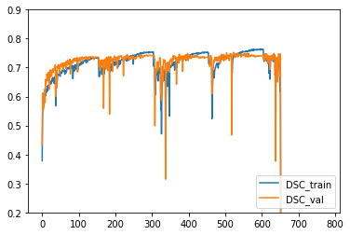

Without augmentation vs. with augmentation [[0.5, 0.5, 0.1, 0.5, 0.5, 0.5, 0.1], [flip, gamma, deform, scale, rotate, shear, translate]]

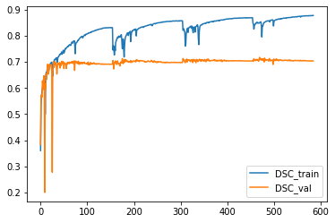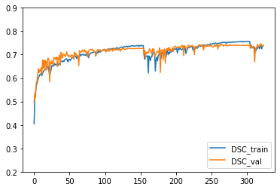

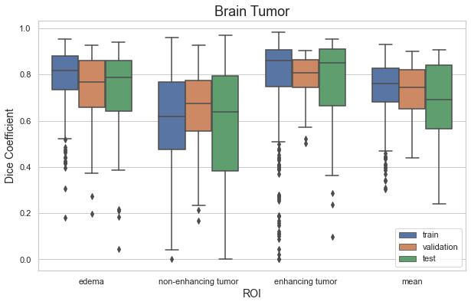

**CT datasets**: picked the two with the greatest number of samples

Pancreas:

* 281 patients with both original image and ROI
* ROI: [0: background, 1: pancreas, 2: cancer]

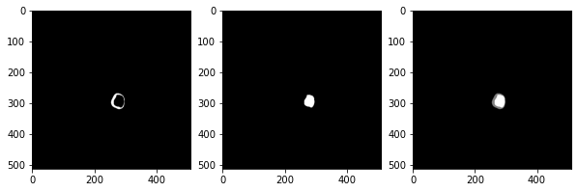

Pancreas, cancer, pancreas + cancer

Hepatic Vessels:

* 303 patients with both original images and ROI
* ROI: [0: background, 1: vessels, 2: cancer]

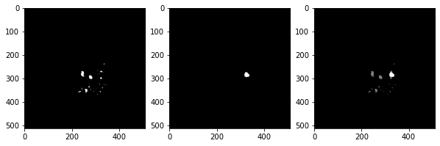

Vessel, tumor, vessel + tumor

CT normalization: global mean and std (of all voxel values of all images)

When normalizing MR imaging, we normalize each image to be mean zero, variance one. When using CT imaging, we still want data to be mean zero, variance one. But since CT units have physical meaning, we can calculate the mean/standard deviation to use over the entire training dataset instead of per patient

I mean exclude outside of the body. when using brain MR, we skull strip the data. and we normalize the image using the brain tissue voxels only. For CT, we crop the body out, and we want to normalize only the body voxels (i.e. ignore the voxels outside the body which we set to zero)

The cropped image is the same size, but unnecessary voxels are zeroed out. Then during training,

we can ignore the zero-voxels since we know those are useless. So it still helps

**Aug 5, 2022**

Model tuning for pancreas and tumor:

Size of pancreas (especially thickness) and tumor ()

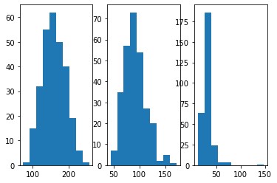

Median: 160.0 90.0 31.0

Augmentation_probability:

[flip = 0, gamma = 0.3, deform = 0.1, scale = 0.3, rotate = 0.3, shear = 0.3, translate = 0.1]

Epoch 1/1000:

201/201 - 304s - hard_dice_coef_metric: 0.0058 - loss: 0.9960 - dice_coef_metric: 0.0040 - val_hard_dice_coef_metric: 0.0032 - val_loss: 0.9979 - val_dice_coef_metric: 0.0021

Epoch 2/1000:

201/201 - 289s - hard_dice_coef_metric: 0.0472 - loss: 0.9952 - dice_coef_metric: 0.0048 - val_hard_dice_coef_metric: 0.3000 - val_loss: 0.9946 - val_dice_coef_metric: 0.0054

Epoch 3/1000

201/201 - 289s - hard_dice_coef_metric: 0.2264 - loss: 0.7792 - dice_coef_metric: 0.2208 - val_hard_dice_coef_metric: 0.2750 - val_loss: 0.7244 - val_dice_coef_metric: 0.2756

Epoch 4/1000

201/201 - 289s - hard_dice_coef_metric: 0.2226 - loss: 0.7756 - dice_coef_metric: 0.2244 - val_hard_dice_coef_metric: 0.2750 - val_loss: 0.7231 - val_dice_coef_metric: 0.2769

Epoch 5/1000

201/201 - 289s - hard_dice_coef_metric: 0.2264 - loss: 0.7727 - dice_coef_metric: 0.2273 - val_hard_dice_coef_metric: 0.3125 - val_loss: 0.6871 - val_dice_coef_metric: 0.3129

Epoch 6/1000

201/201 - 289s - hard_dice_coef_metric: 0.2600 - loss: 0.7383 - dice_coef_metric: 0.2617 - val_hard_dice_coef_metric: 0.3000 - val_loss: 0.6996 - val_dice_coef_metric: 0.3004

…

Epoch 19/1000:

201/201 - 289s - hard_dice_coef_metric: 0.2438 - loss: 0.7545 - dice_coef_metric: 0.2455 - val_hard_dice_coef_metric: 0.2125 - val_loss: 0.7871 - val_dice_coef_metric: 0.2129

…

Epoch 38/1000

201/201 - 289s - hard_dice_coef_metric: 0.2338 - loss: 0.7653 - dice_coef_metric: 0.2347 - val_hard_dice_coef_metric: 0.2875 - val_loss: 0.7122 - val_dice_coef_metric: 0.2878

…

Why underfitting? (validation higher than training)

201/201 - 289s - hard_dice_coef_metric: 0.7239 - loss: 0.2744 - dice_coef_metric: 0.7256 - val_hard_dice_coef_metric: 0.8000 - val_loss: 0.1978 - val_dice_coef_metric: 0.8022

Epoch 226/1000

201/201 - 289s - hard_dice_coef_metric: 0.7040 - loss: 0.2944 - dice_coef_metric: 0.7056 - val_hard_dice_coef_metric: 0.8375 - val_loss: 0.1623 - val_dice_coef_metric: 0.8377

Epoch 227/1000

201/201 - 289s - hard_dice_coef_metric: 0.7301 - loss: 0.2679 - dice_coef_metric: 0.7321 - val_hard_dice_coef_metric: 0.7500 - val_loss: 0.2489 - val_dice_coef_metric: 0.7511

…

Epoch 537/1000

201/201 - 289s - hard_dice_coef_metric: 0.7463 - loss: 0.2530 - dice_coef_metric: 0.7470 - val_hard_dice_coef_metric: 0.8000 - val_loss: 0.1992 - val_dice_coef_metric: 0.8008

Epoch 538/1000

201/201 - 289s - hard_dice_coef_metric: 0.7326 - loss: 0.2662 - dice_coef_metric: 0.7338 - val_hard_dice_coef_metric: 0.7500 - val_loss: 0.2447 - val_dice_coef_metric: 0.7553

Epoch 539/1000

201/201 - 289s - hard_dice_coef_metric: 0.7264 - loss: 0.2718 - dice_coef_metric: 0.7282 - val_hard_dice_coef_metric: 0.7500 - val_loss: 0.2471 - val_dice_coef_metric: 0.7529

Pancreas training results:

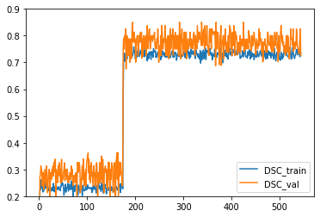

Epoch22: 201/201 - 288s - dice_coef_metric: 0.1585 - hard_dice_coef_metric: 0.1580 - loss: 0.8415 - val_dice_coef_metric: 0.1753 - val_hard_dice_coef_metric: 0.1750 - val_loss: 0.8247

Epoch 23/1000

201/201 - 289s - dice_coef_metric: 0.1447 - hard_dice_coef_metric: 0.1443 - loss: 0.8553 - val_dice_coef_metric: 0.1378 - val_hard_dice_coef_metric: 0.1375 - val_loss: 0.8622

Epoch 24/1000

201/201 - 289s - dice_coef_metric: 0.1300 - hard_dice_coef_metric: 0.1294 - loss: 0.8700 - val_dice_coef_metric: 0.1660 - val_hard_dice_coef_metric: 0.1625 - val_loss: 0.8340

epoch 25/1000

201/201 - 289s - dice_coef_metric: 0.1241 - hard_dice_coef_metric: 0.1231 - loss: 0.8759 - val_dice_coef_metric: 0.2003 - val_hard_dice_coef_metric: 0.2000 - val_loss: 0.7997

Aug 23, Tue, 2022:

Loss = joint_dice_cross_entropy_loss

def joint_dice_cross_entropy_loss(y_true, y_pred):

loss_contribution1 = tf.multiply(DecayAlphaParameter.alpha1, dice_coef_loss(y_true, y_pred))

loss_contribution2 = tf.multiply(DecayAlphaParameter.alpha2, weighted_cross_entropy_loss(y_true, y_pred))

return tf.add(loss_contribution1, loss_contribution2)

reweight foreground class = [1.0, 2.0, 4.0] pancreas = 2, tumor = 4

Epoch 206/1000

201/201 - 122s - hard_dice_coef_metric: 0.7986 - loss: 0.2562 - dice_coef_metric: 0.7823 - val_hard_dice_coef_metric: 0.6999 - val_loss: 0.3656 - val_dice_coef_metric: 0.6944

Epoch 207/1000

201/201 - 122s - hard_dice_coef_metric: 0.8563 - loss: 0.2010 - dice_coef_metric: 0.8458 - val_hard_dice_coef_metric: 0.8002 - val_loss: 0.2472 - val_dice_coef_metric: 0.7865

* Could it be something wrong with the joint loss function? What is this loss function outputting? (what about using Jaccard?)
* Reweight foreground class weight:

(2,4,2) 🡪 still only tumor

(1,4,2) 🡪 ???

* Background sample probability = 0.1 (too small), 0.3 (good, but only tumor), 0.5 (___), 0.25 (good, but only tumor)
* Batch size (2,2,2 🡪 only tumor; 4,4,4 🡪 ??)
* Patch overlap = 0.85 for both training and testing (0.5 train, 0.85 predict 🡪 only tumor)
* Other solution: maybe recreate windowed images (larger window…) + other labels

Due to ROI overlap, can I try binary maybe??? Pancreas + tumor

What is this dice coef returning? Does it include background class?

(1,4,2), 0.25 background_sample; patch overlap = 0.85; 🡪 nothing showing

Epoch 7/500

201/201 - 636s - loss: 0.3830 - hard_dice_coef_metric: 0.6737 - dice_coef_metric: 0.6602 - val_loss: 0.3814 - val_hard_dice_coef_metric: 0.6591 - val_dice_coef_metric: 0.6448

Epoch 8/500

201/201 - 635s - loss: 0.3651 - hard_dice_coef_metric: 0.6887 - dice_coef_metric: 0.6736 - val_loss: 0.4018 - val_hard_dice_coef_metric: 0.6446 - val_dice_coef_metric: 0.6427

…

Epoch 14/500:

201/201 - 636s - loss: 0.3264 - hard_dice_coef_metric: 0.7149 - dice_coef_metric: 0.7075 - val_loss: 0.3479 - val_hard_dice_coef_metric: 0.6920 - val_dice_coef_metric: 0.6791

Epoch 15/500

201/201 - 636s - loss: 0.3110 - hard_dice_coef_metric: 0.7267 - dice_coef_metric: 0.7190 - val_loss: 0.3285 - val_hard_dice_coef_metric: 0.7074 - val_dice_coef_metric: 0.6982

…

Epoch 60/500:

201/201 - 635s - loss: 0.2181 - hard_dice_coef_metric: 0.8066 - dice_coef_metric: 0.8007 - val_loss: 0.2882 - val_hard_dice_coef_metric: 0.7361 - val_dice_coef_metric: 0.7306

Epoch 61/500

201/201 - 635s - loss: 0.1995 - hard_dice_coef_metric: 0.8235 - dice_coef_metric: 0.8172 - val_loss: 0.3599 - val_hard_dice_coef_metric: 0.6864 - val_dice_coef_metric: 0.6788